Restaurant Deals and Vouchers
Meerkat Movies & Meals 2for1 cinema AND restaurants  How to get a year's 2for1 from £1ish. Click on this link for more info | 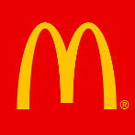  McDonald's food hacks  Including £2.70 off 'McChicken sandwich'
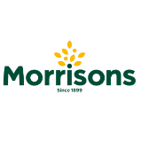  Feed a family of four for £10 at Morrisons Café - Including two adult meals, two kids meals and drinks  Morrisons Café kids eat 'free'  Every day when purchasing an adult main meal for £4.99+. Valid every day | 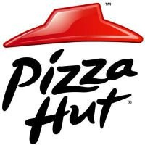  Pizza Hut £9 UNLIMITED lunch buffet - Eat as much pizza, pasta & salad as you like for a set price
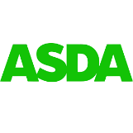  Asda Cafés kids eat for £1  No minimum spend required | 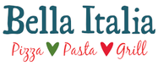  Bella Italia kids eat for '£1' - Valid when adult buys a main meal. Mon-Thu, 4pm-6pm only
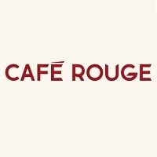  Café Rouge kids eat for '£1'  When a full-price adult main is purchased. Excludes Saturdays. | Dobbies kids eat for ‘free’  Valid when an adult main meal is purchased
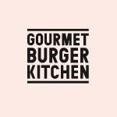  Gourmet Burger Kitchen kids eat for 'free' - Every day with the purchase of adult main meal | 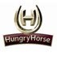  Hungry Horse 'free' kids' breakfast  When an adult buys a breakfast from £3.49 from 9-12 am  Hungry Horse kids eat from £1  Mondays only. When adults buy a main meal
Sizzling Pubs kids eat for '£1'  Every Monday to Friday, 3 - 7 pm you can get a kids’ main for just £1 with the purchase of an adult meal. | 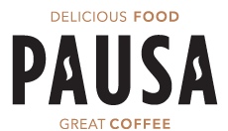  From June 27th 2022 children get 1 mini main, 2 snacks and a drink FREE with every £4 spend at Pausa Cafes at Dunelm stores.
Kids eat free all day, every day with paying adults at Preto. This offer is open to children up to 10 years old - This is an ongoing offer! | Purchase one great value £9.50 breakfast at any Whitbread Inns pub or restaurant and two kids under 16 eat for FREE
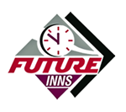  At Future Inns, under 5's always eat for free with any adult meal. During the school holidays, it's extended to under 12's. | Two children under 16 years old can get a free breakfast every day with one paying adult!
Two children get free breakfast with one paying adult! It has also been reported that if you sign up for their newsletter, they send out a code for kids to eat free, but I haven't personally tried this. | The same as Beefeater, you can get two children free breakfast with one paying adult! It has also been reported that if you sign up for their newsletter, they send out a code for kids to eat free, but I haven't personally tried this.
Kid’s eat free from 3pm-5.30pm, Monday to Thursday until 1st September 2022 | Kids eat FREE every Sunday for every £10 spent by an adult.
Kids under 10 can eat free from the children’s menu when grown-ups order mains from the main menu.  Available every day 12pm - 5pm. | Until the 3rd of September, kids can enjoy any meal from the children's menu for 95p, or £1.50 for a combo meal which includes one hot meal, jelly, a soft drink, and a piece of fruit.
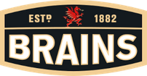  Children can eat for £1 with any adult main. The offer is valid Wednesdays only but all day. | 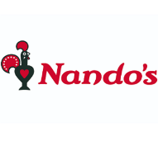  Nando's MoneySaving tips & hacks  It rarely does deals but we've a list of ways to help you save
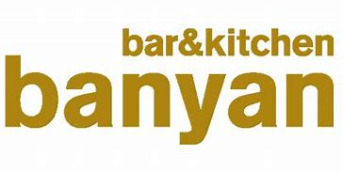  Kids eat for free when you purchase an adult meal, Mon-Fri until 6pm. | 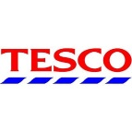  Kids eat for free when an adult clubcard member makes a purchase in the cafe

Takeaway food & drink deals

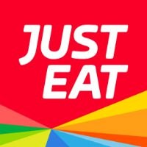  Just Eat 10%-30% off selected takeaways  Check for a red flag to see if your local is included | 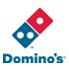  Domino's 2for1 pizzas (Tuesdays)  Order online, in-store or over the phone

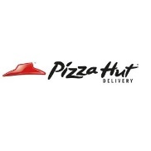
Pizza Hut Delivery 2for1 (Tuesdays)
Online or phone code for delivery or collection

